

**UNIVERSITY OF PETROLEUM & ENERGY STUDIES**

**Dehradun**

**CONTINOUS INTEGRATION**

**AND**

**CONTINOUS DELIVERY**

**Name: Aakarshit Agarwal**

**Course: B. TECH CSE DevOps (2018-22)**

**Roll no.: R171218001**

**Sapid: 500067782**

**Experiment-13**

**Deploying your first Docker Container**

**Step 1 - Running a Container**

docker search <name>

docker search redis

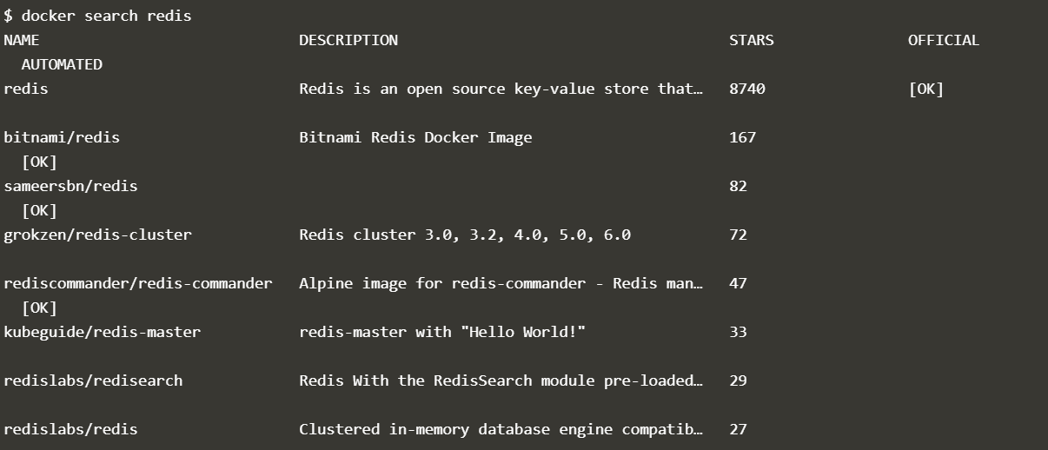

docker run <options> <image-name>

docker run -d redis



**Step 2 - Finding Running Containers**

docker ps

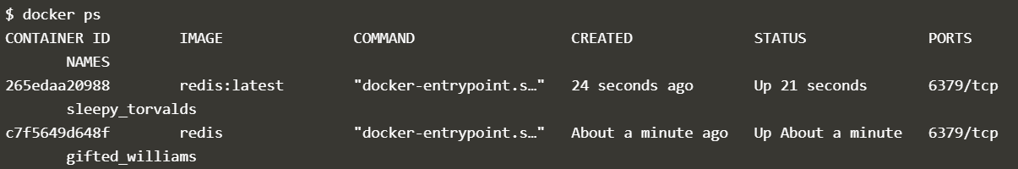

docker inspect <friendly-name|container-id>

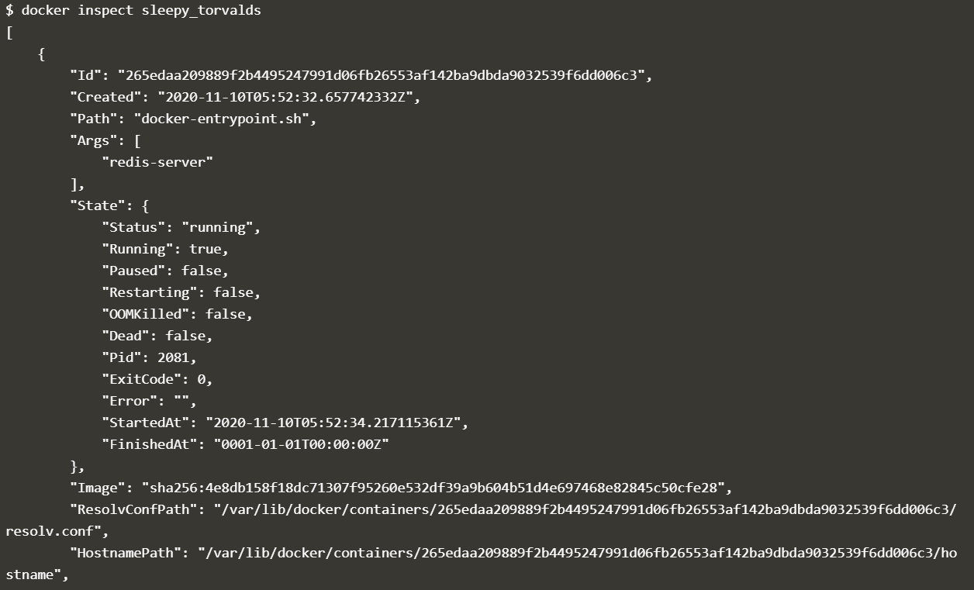

docker logs <friendly-name|container-id>

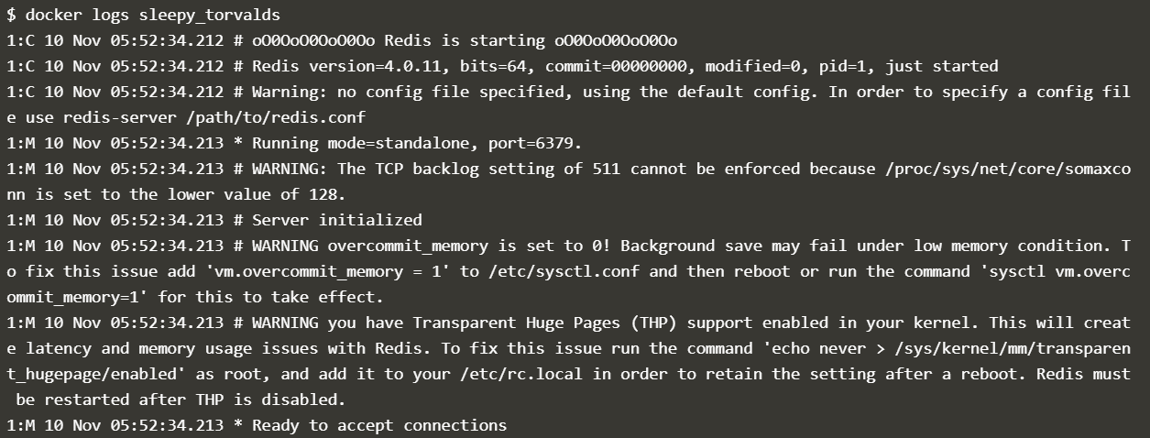

**Step 3 - Accessing Redis**

docker run -d --name redisHostPort -p 6379:6379 redis:latest



**Step 4 - Accessing Redis**

docker run -d --name redisDynamic -p 6379 redis:latest

docker port redisDynamic 6379

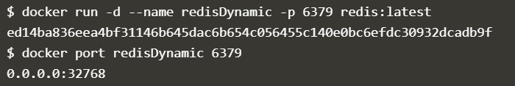

docker ps

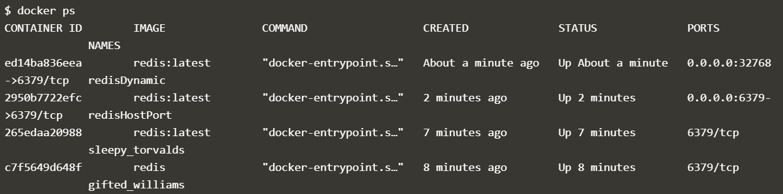

**Step 5 - Persisting Data**

docker run -d --name redisMapped -v /opt/docker/data/redis:/data redis



**Step 6 - Running A Container In The Foreground**

docker run -it ubuntu bash

